Quick Start Operations Guide for VMware ESXi 5.1
Chris Morgan
2014

Installing VMWare ESXi
VMWare ESXi is a free bare-metal hypervisor solution. In order to obtain the software and a free license key, create a VMWare.com account, find the ESXi product and follow the instructions on the website.
Once the ESXi .iso has been procured, burn it to disc and insert it into the system on which it will be installed.
Boot from the disc and start the ESXi installer.
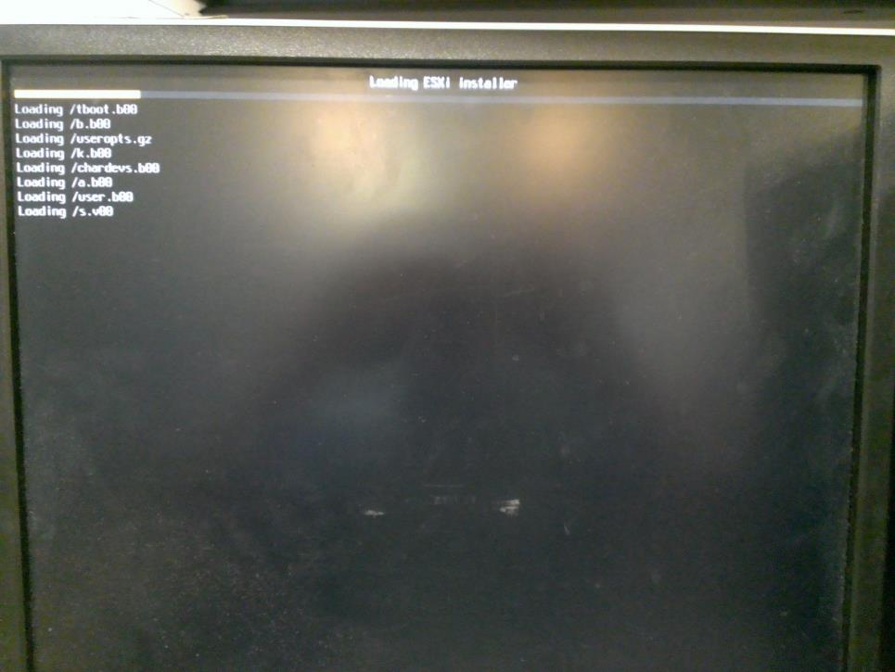

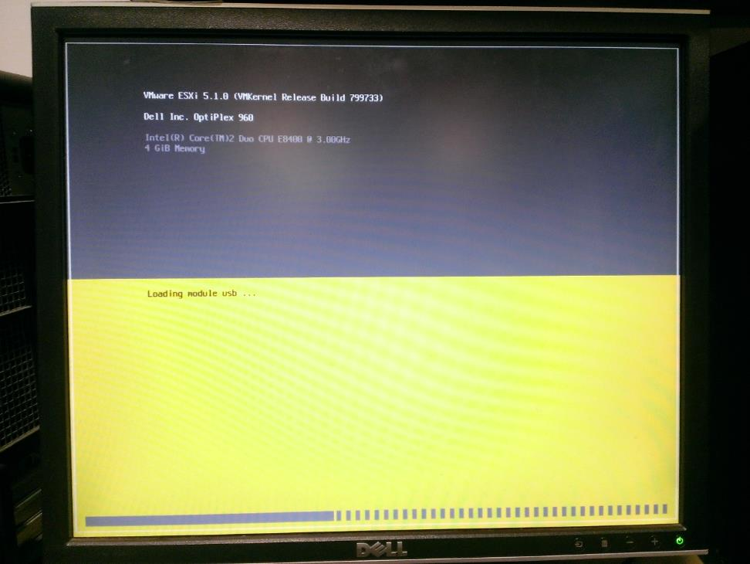
Press Enter to start the installer and F11 to accept the license agreement.
Select a disk to install the ESXi hypervisor on. This image shows only one disk but the system should be installed on a machine with at least two drives, one for the base system and one for storing the VMs.
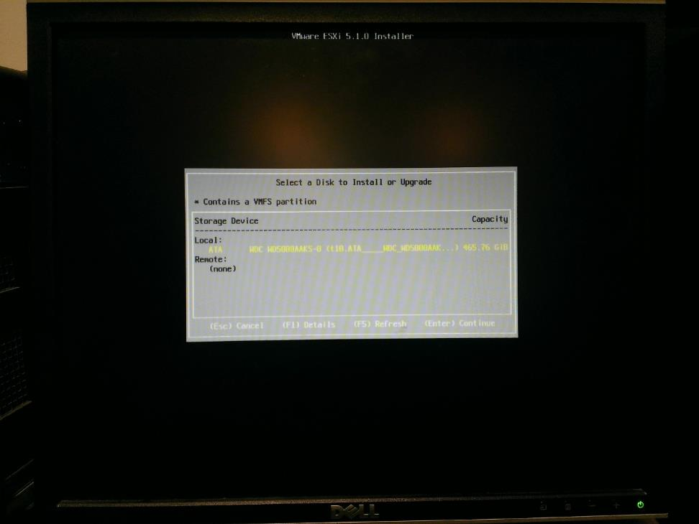
Confirm the disk selection by pressing Enter.
Select a keyboard layout.
Create a root password.
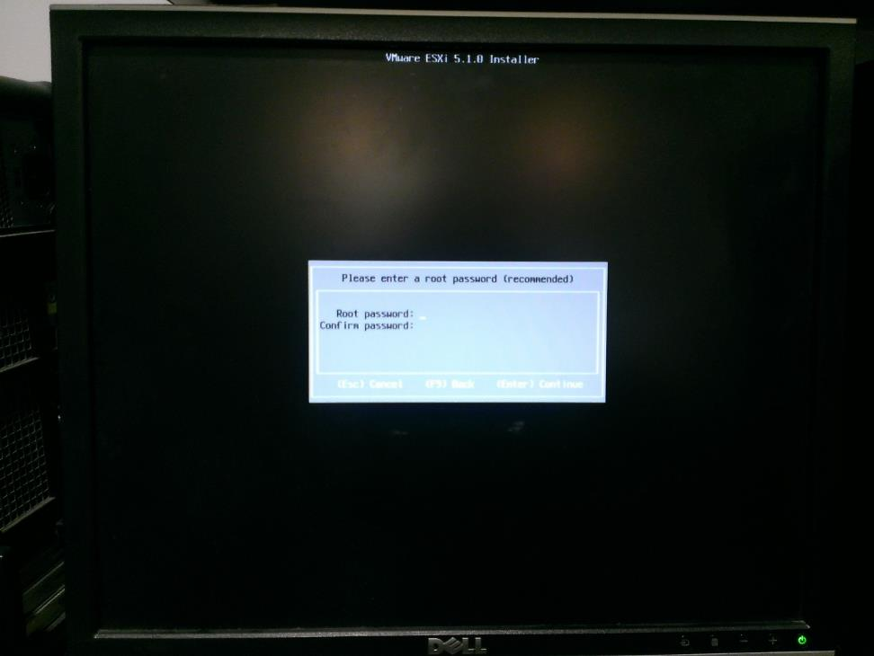
During the next step, it is possible that this warning about Hardware Virtualization being turned off will present itself. If so, after install completes, go into the system BIOS and turn on the CPU's virtualization technology.
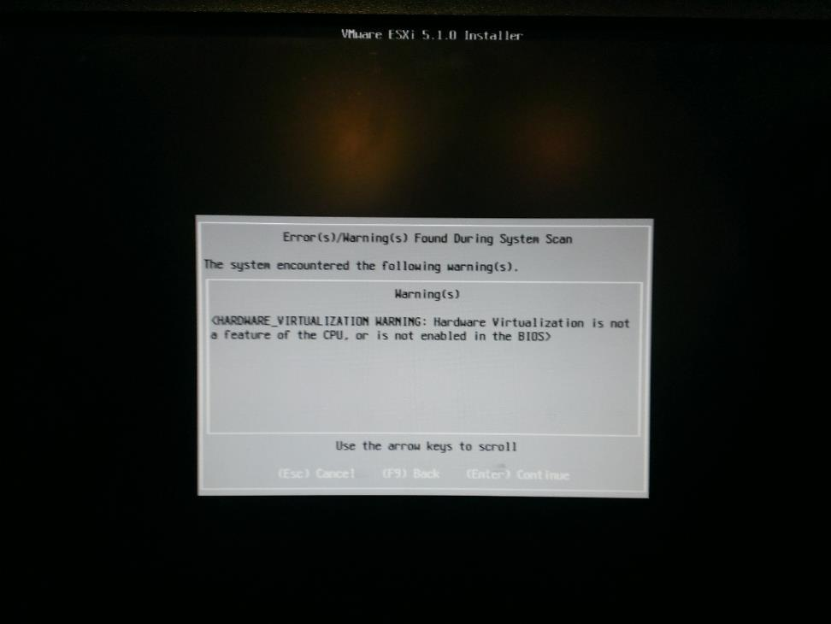
Confirm and start the install by pressing F11.
Once the installation completes, press Enter to reboot.

Configuring the Base ESXi System
Once ESXi is installed, the UI on the actual system is rather limited and only gives you options for configuring the most basic of options. Most configuration is performed from client machines through the VMWare vSphere Client software.
Once the system boots, you will see the following screen:
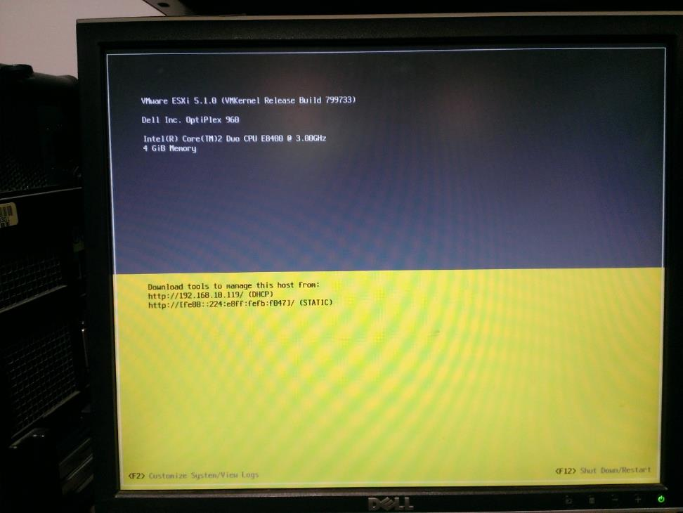
The only thing that needs to be configured here is the base system networking. Press F2 to login to the system with the "root" account and the password that was set during setup.
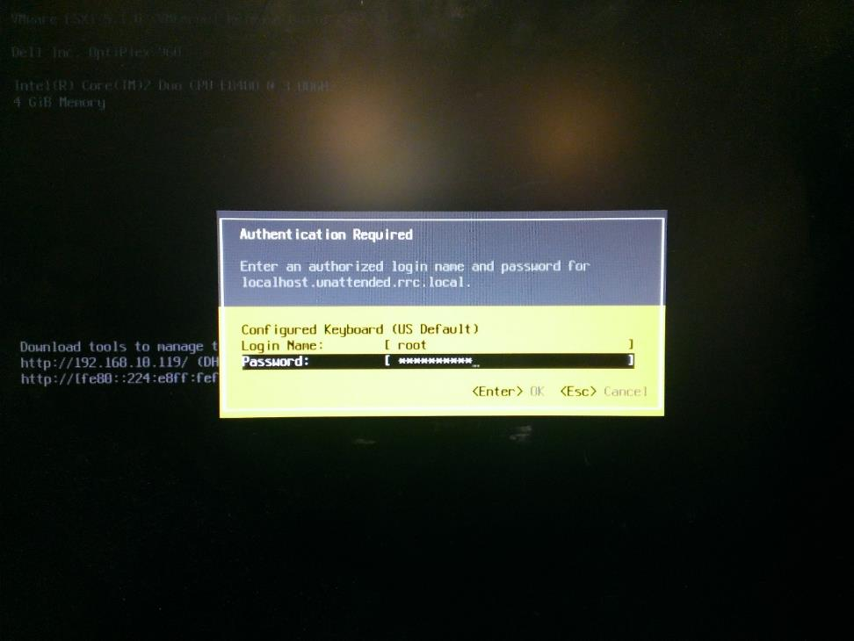
Select "Configure Management Network"
In this screen, select "IP Configuration" and input the following options to configure this ESXi system, then press Enter to exit.
Necessary configuration information:
IP Address
Subnet Mask
Default Gateway

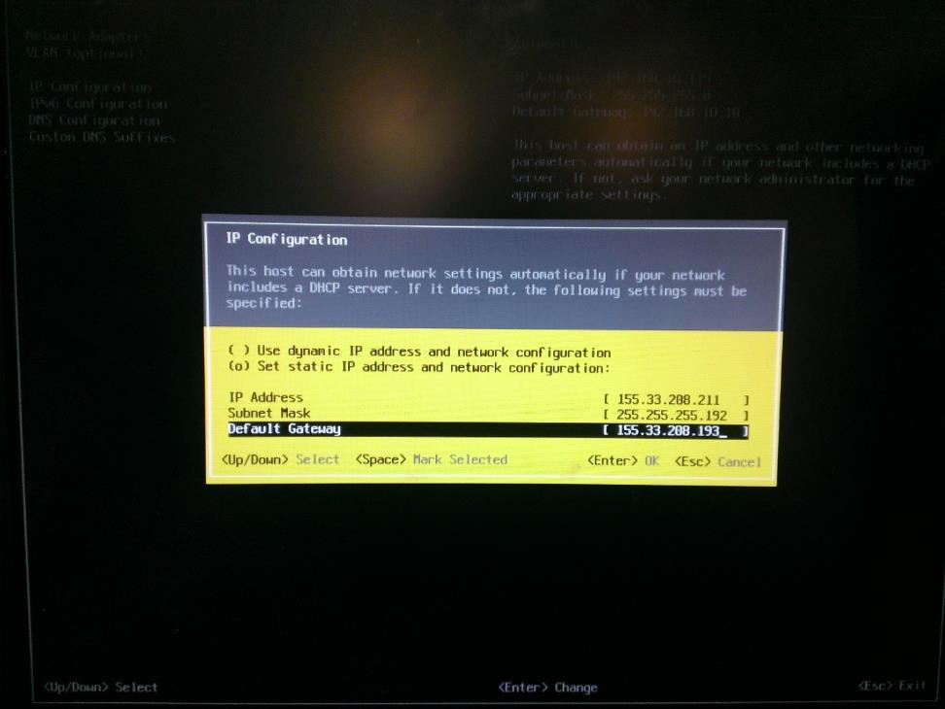
Back in the "Configure Management Network" menu, select "DNS Configuration" and enter the following options then press Enter:
Necessary configuration information:
Primary DNS Server
Alternate DNS Server
Hostname
Finally, in the "Configure Management Network" menu, select "Custom DNS Suffixes" and enter the following then press Enter:
Necessary configuration information:
DNS Suffixes
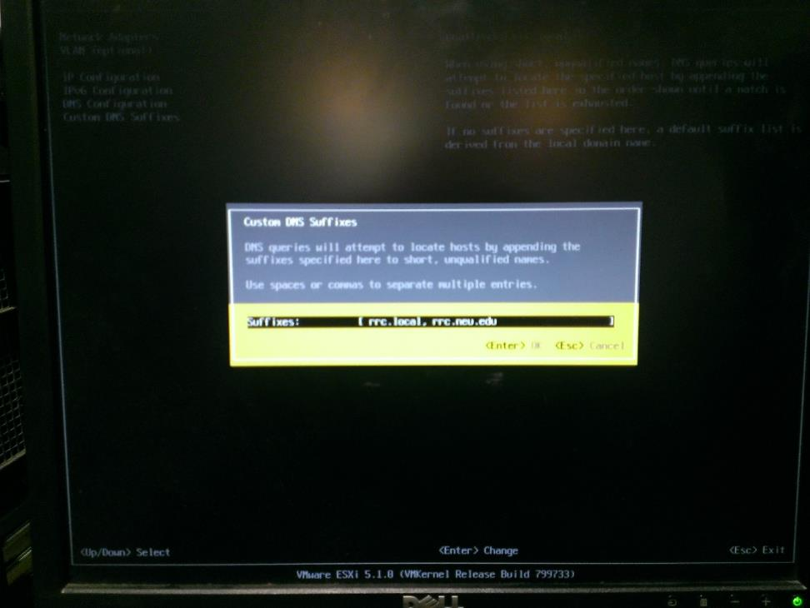
Press ESC to exit the "Configure Management Network" menu and press Y to apply the networking changes.
Press ESC to logout of the ESXi system.

Accessing ESXi from a Client and Performing Initial Configuration
Now that networking is configured on the system, the system can be accessed by any computer running the vSphere Client software. Unforunately, this software is Windows-only. The software can be obtained by going to https://<SYSTEM_IP>/, accepting the self-signed certificate error, then clicking the "Download vSphere Client" link.
Once the software downloads, start the installation. The installation is a little odd and after it unpacks itself and you select a few options, the installer window will disappear for a few minutes before it pops back up and completes the installation.
Launch the vSphere Client software. At the login screen, enter the full DNS hostname of the system or the IP address, then the "root" username and password. Press Login to connect to the system. Press Ignore to bypass the self-signed certificate warning.
This is the main page that is displayed when a system administrator signs in. Servers and the VMs which exist on it are displayed in the left pane and configuration options for the object selected in the left pane are displayed in the right pane.
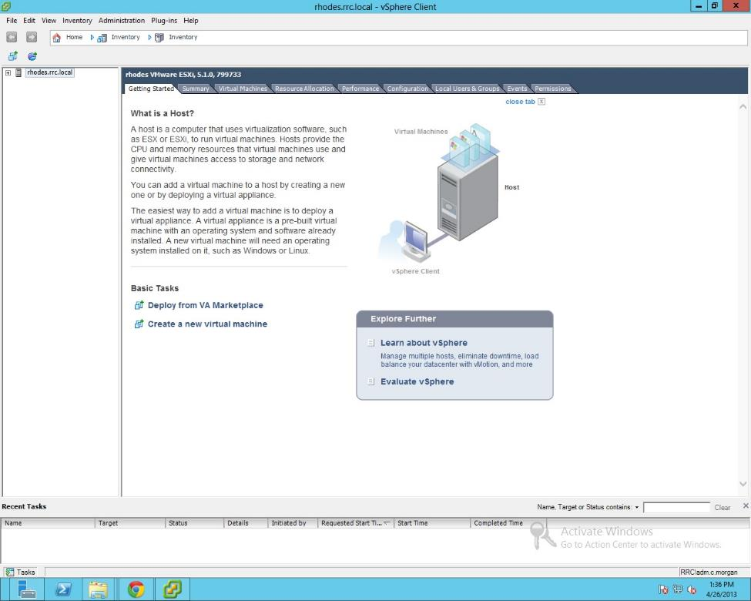
In the "Configuration" tab, select "Storage." ESXi uses a proprietary file system and stores files in items called datastores. The base system disk's datastore will be labelled "datastore1." There will be unallocated storage on the second disk that should be in the system. In order to use this disk as a datastore, it first needs to be configured. If previous partitions and filesystems exist on the disk, then ESXi will throw an error when trying to configure the disk, so use GParted in Ubuntu to create a new MSDOS partition table on the disk first and leave the entire disk as unallocated space. Once this is done, boot the ESXi system up again, connect with vSphere Client and navigate back to the Storage page. Once there, select "Add Storage..." in the top right. Choose "Disk/LUN" as the storage type and hit Next. Select the disk for the datastore to be created on and follow the rest of the steps in the wizard. Name this datastore "Virtual Machines" when given the option to name it. With this complete, the Storage screen should look like this:
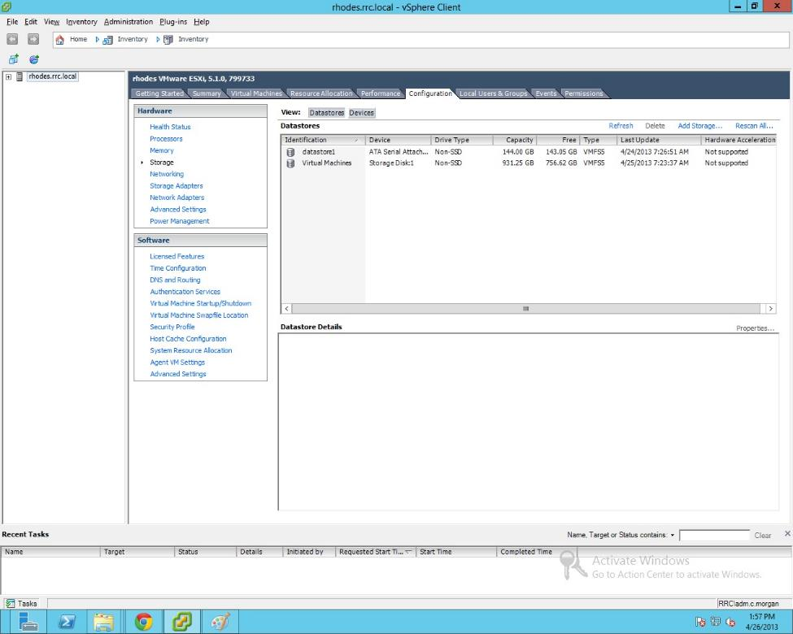
To enter a datastore, right-click it and select "Browse Datastore..."
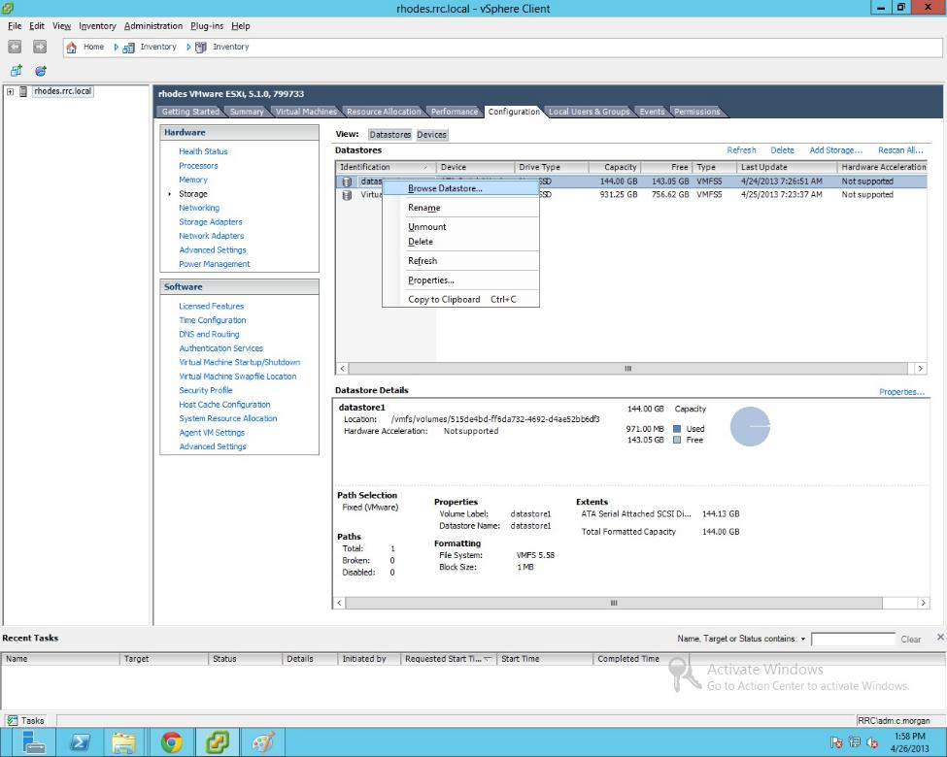
In datastore1, we want to create a folder for the ISOs which will be used to boot systems. In the root of datastore1, create a folder called ISOs.
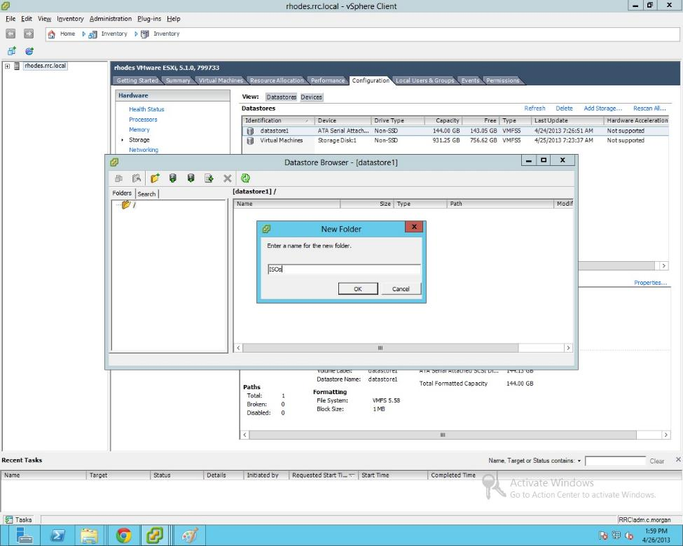
Then, select the "ISOs" folder and upload the appropriate ISOs to this folder. It will be easier to create and use VMs using ISOs than with physical disks, so it is a good idea to store many ISOs in this folder, including setup ISOs for whichever operating systems you would like to install on VM guests.
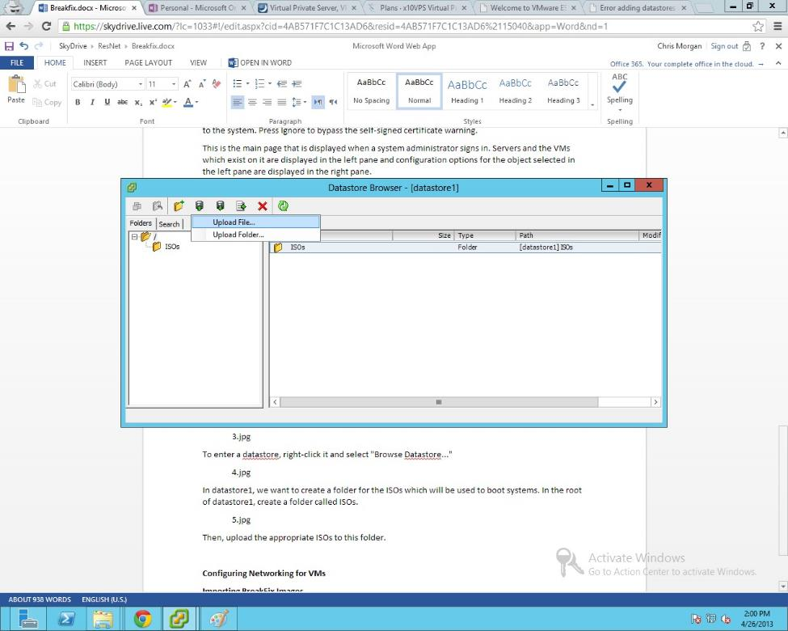
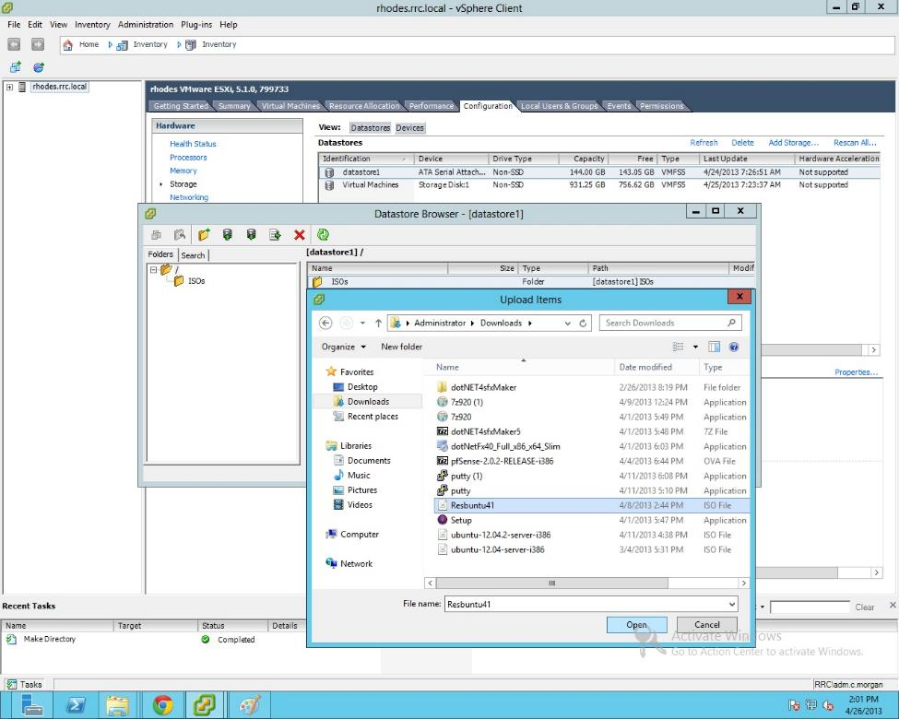
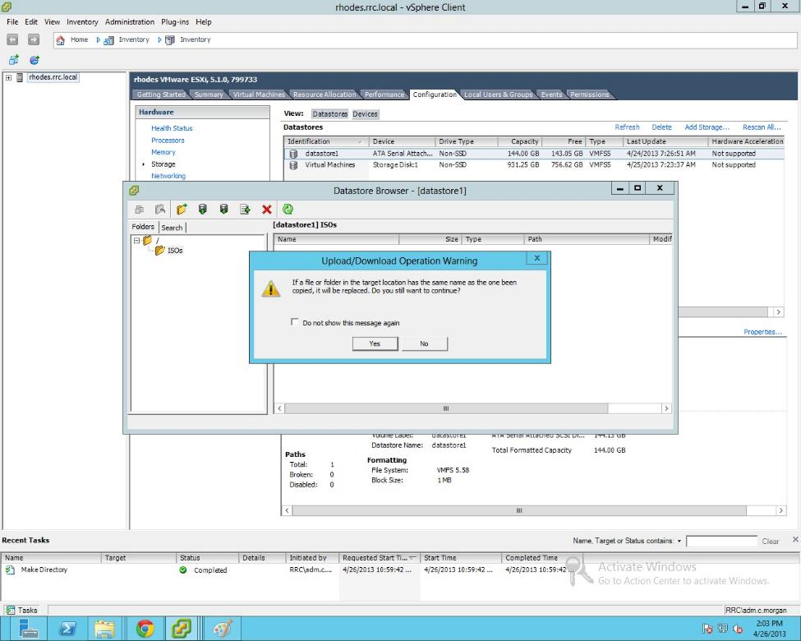
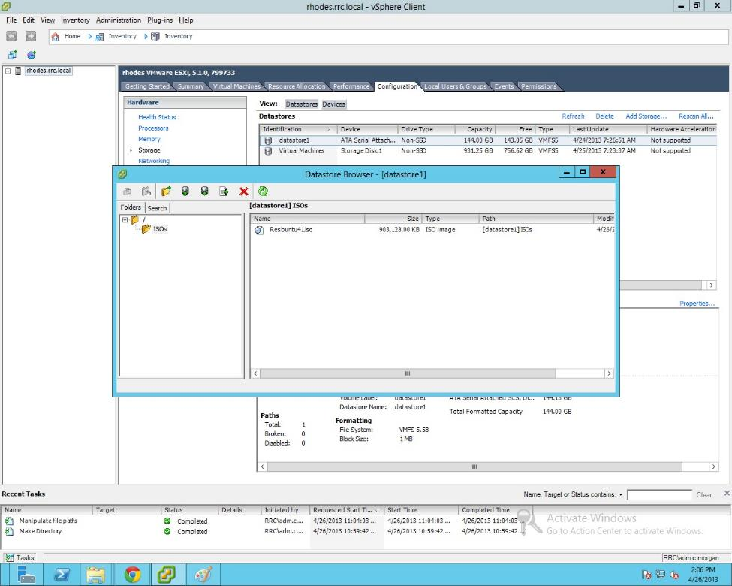

Optional Step: Active Directory Domain Authentication and Authorization
Make sure the server name is selected in the left pane, then select the "Configuration" tab in the right pane. Under "Software" select "Authentication Services" then select "Properties..." in the top right. In the resulting window, change "Select Directory Service Type:" to "Active Directory." Enter the domain name in the "Domain" field then click Join Domain. Enter admin credentials which are capable of joining the system to the domain. The final screen should look like the following picture once the system is connected to the domain. Press OK to exit this screen.
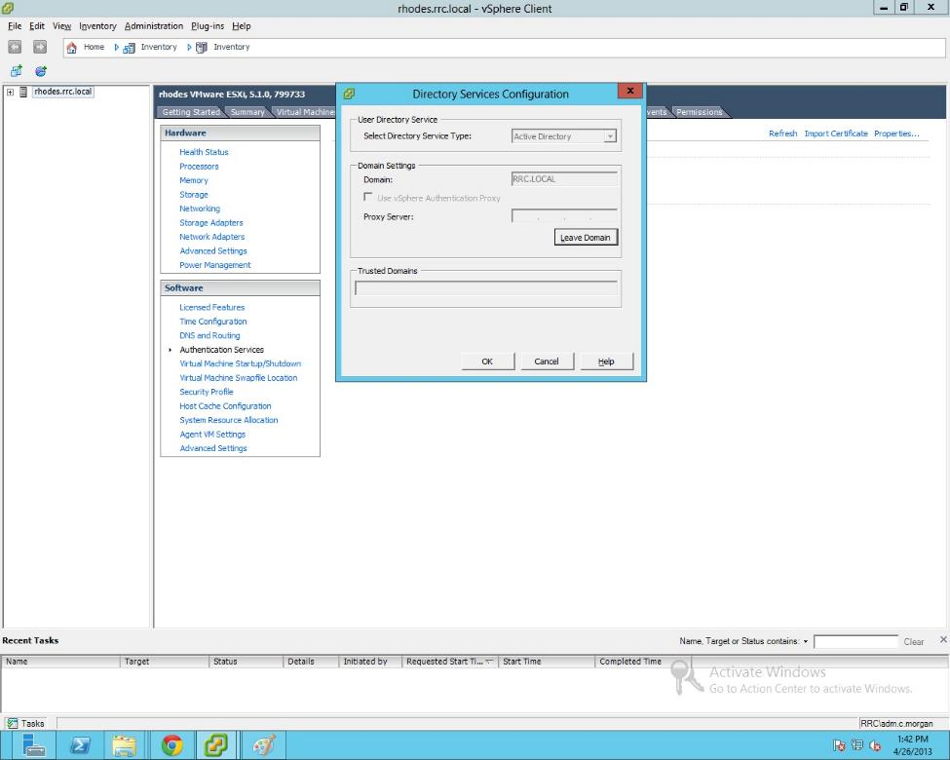

Change from the "Configuration" tab to the "Permissions" tab, right-click in the white area and click "Add Permission..." Change the Assigned Role dropdown box to "Administrator."
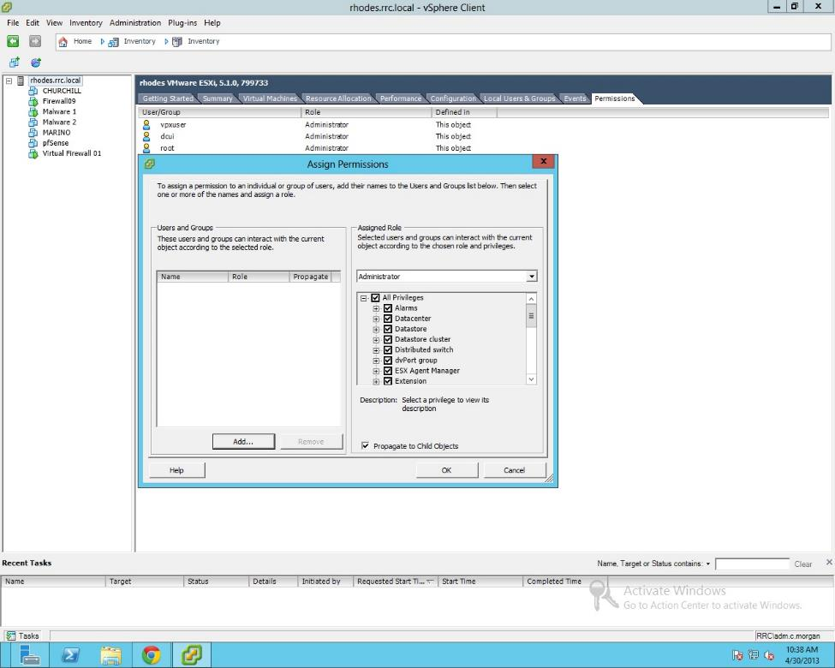
Click "Add..." under Users and Groups. In the resulting window, change Domain to RRC and the Users and Groups dropdown to Show Groups First. Find the AD group which should be allowed to administer this system in the list and press Add. Click OK to close the window.
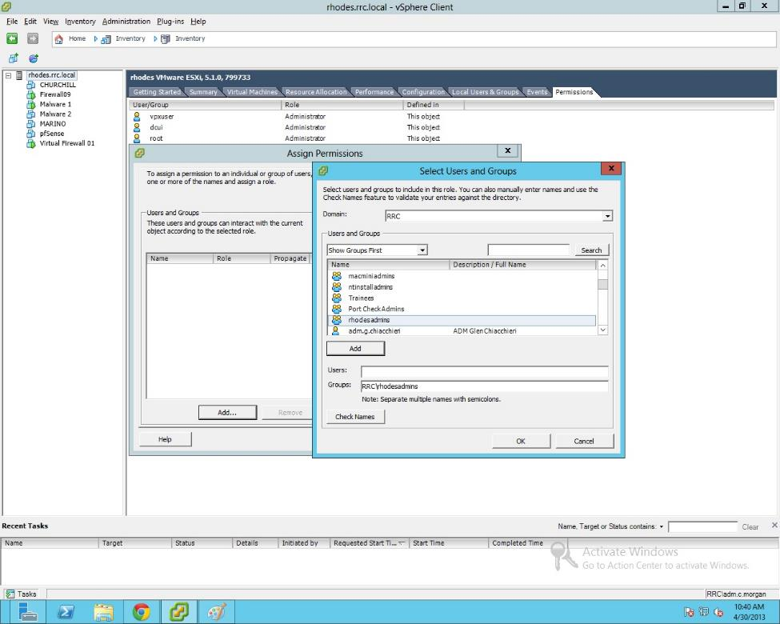
Click OK to close the "Assign Permissions" window.
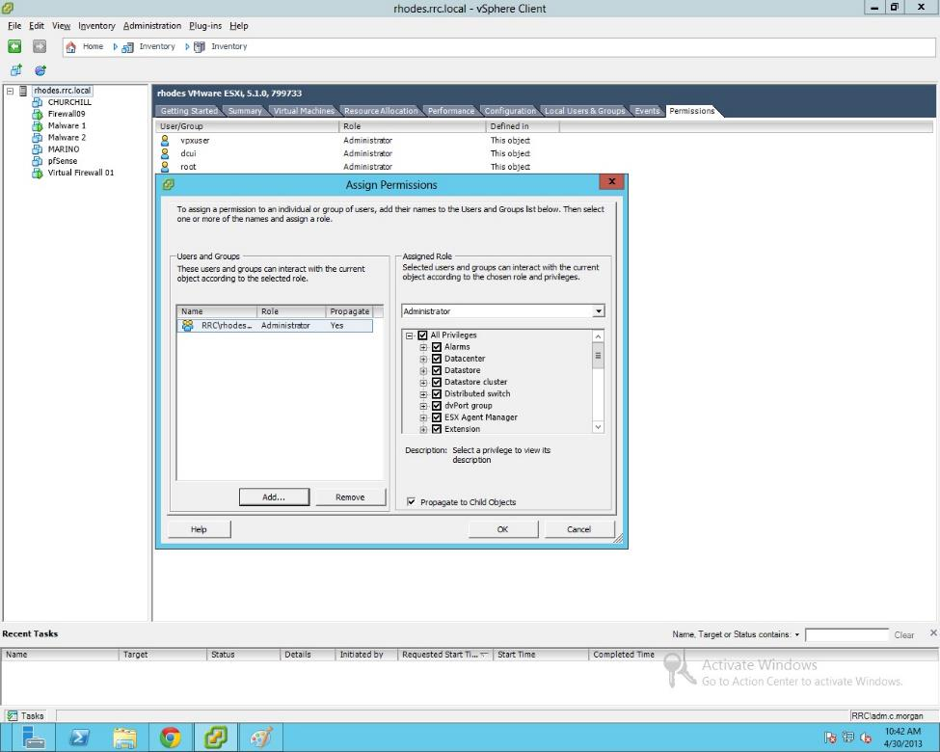
The resulting Permissions tab for the ESXi server should look as follows.
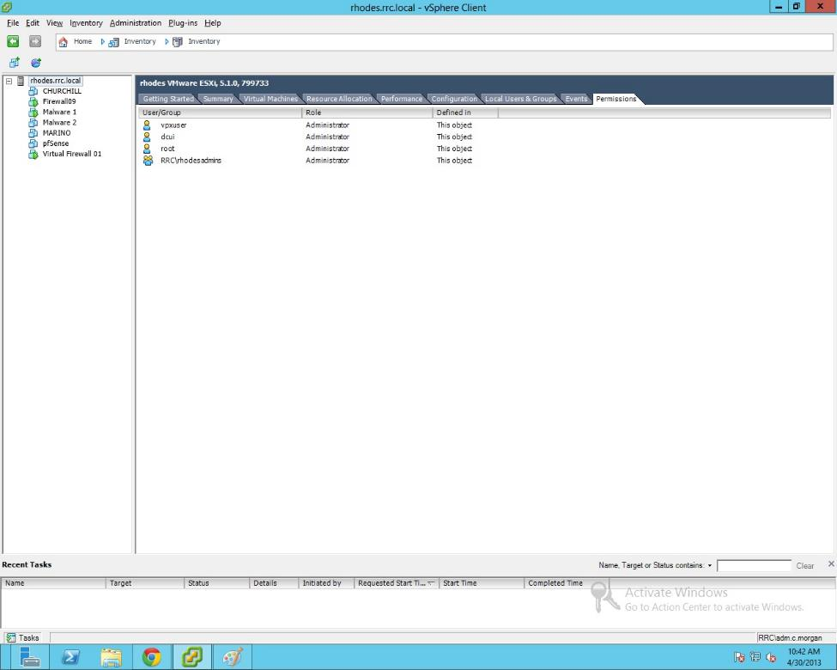
From this point forward, the "root" account should not be used to login to the ESXi system. With the system joined to the domain, AD accounts should be used to login to the system. To login with an AD account which has permissions on this system, the username must be preceded with the domain short name at the login window. For instance: RRC\adm.c.morgan
With this initial configuration completed, we can now begin to configure the most complicated part of ESXi, the internal virtual networking configuration.

Using and Maintaining ESXi: Creating new VMs, Accessing VMs, and Exporting

Create a VM
To start creating a new virtual machine, select the server in the left pane, right-click and select "New Virtual Machine..."
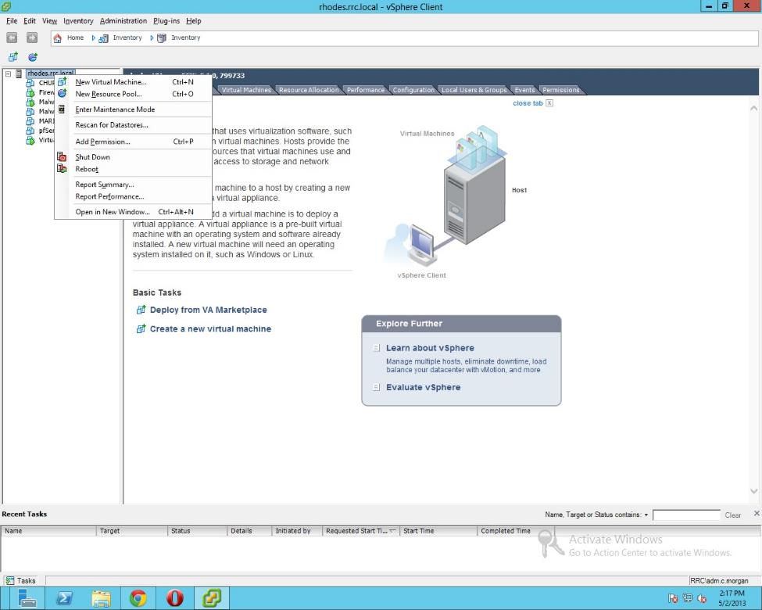
Select "Typical" in the first screen, click Next, name the virtual machine in the second screen, then click Next again.
In the Storage screen, select the "Virtual Machines" datastore as the location in which the new virtual machine will be stored, then click Next.
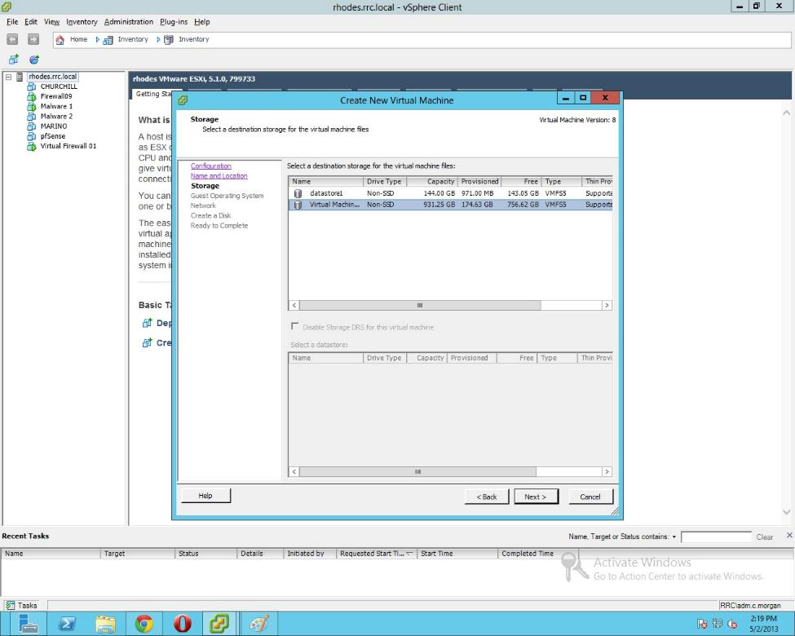
Select the type of operating system which the virtual machine will run, then click next.
In this screen, select how many virtual NICs will be connected to the machine. For each NIC, select the virtual network it will be connected to. Click Next when this configuration is completed.
Change the virtual disk size to be the needed storage capacity, then click Next.
In the final screen, make sure all of the settings have been properly selected, then click Finish.

Access a VM
From the main vSphere Client interface, select the machine in the left pane which you would like to access.
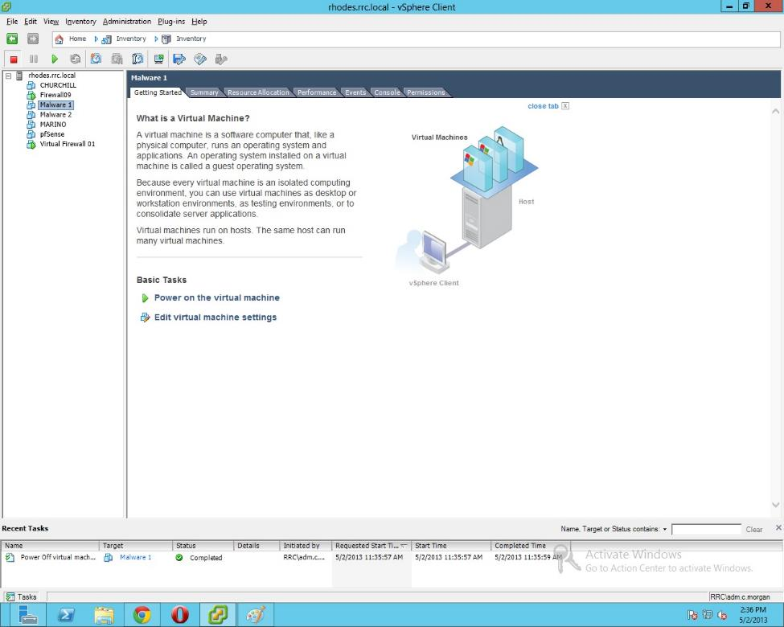
In the right pane, select the "Console" tab, which will give a direct output from the virtual machine.
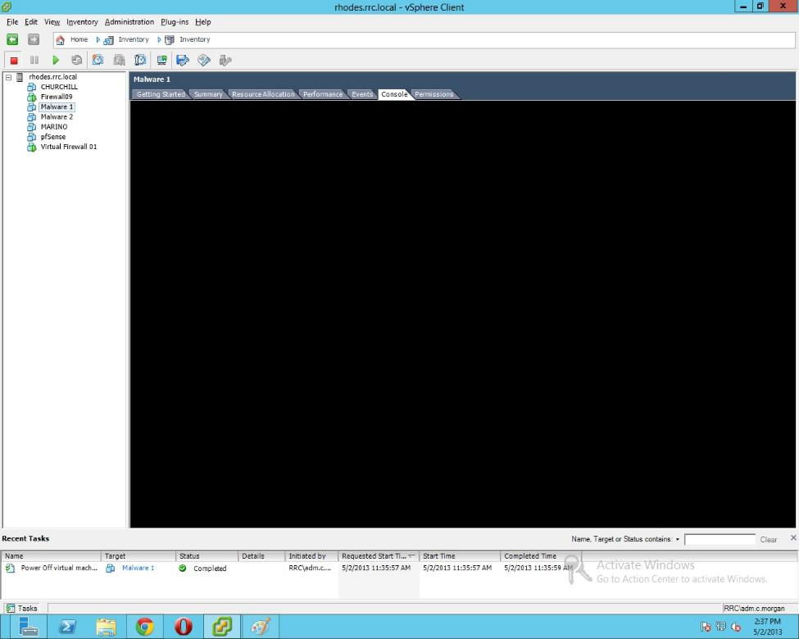
Obviously, in order for there to be output, the machine must be turned on, so press the green play button directly above the left pane to turn the machine on.
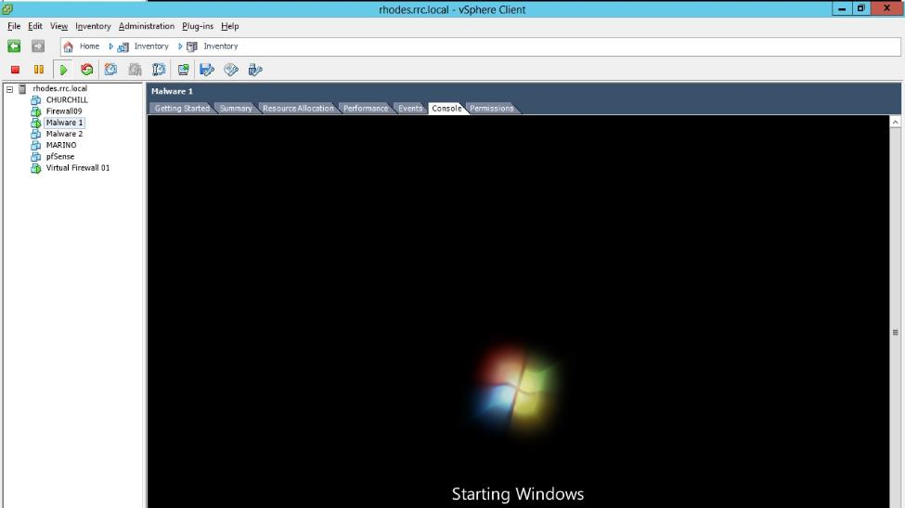
To boot from a source other than the hard drive, you must edit the virtual machine's settings. Right click the machine in the left pane and select Edit Settings...
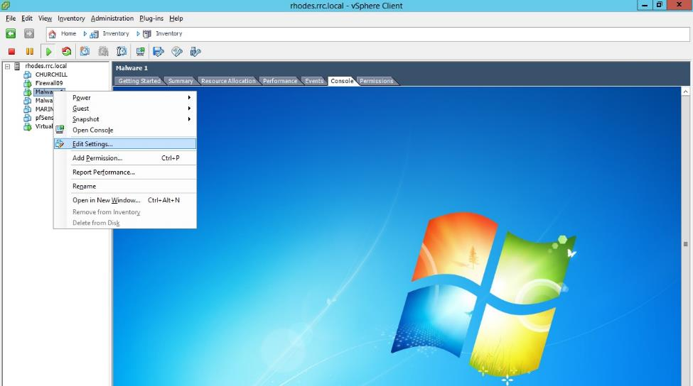
In order to boot to the BIOS directly on the next restart, click the Options tab and select the Force BIOS Entry option box. If this option is selected, then in the BIOS you will be able to change the boot order to make the machine pXe boot or boot from a disk.
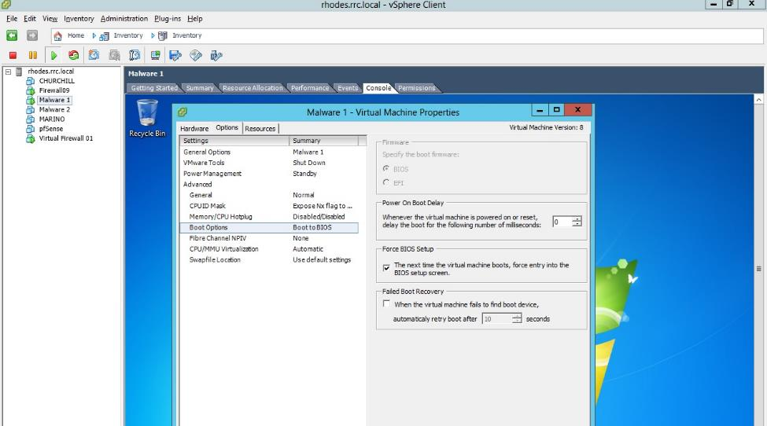
To select an ISO to boot from, go back to the "Edit Settings..." window, select the CD/DVD drive and select the Datastore ISO File option.
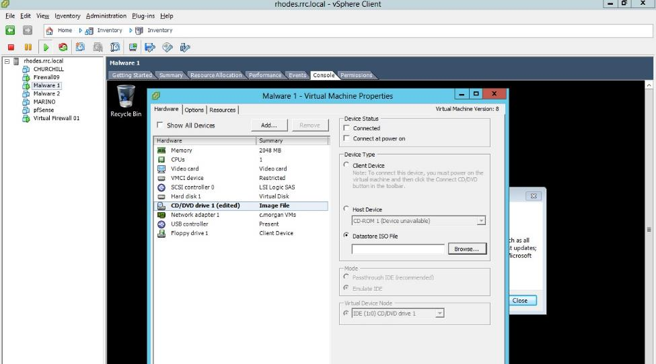
Select browse, then enter the appropriate datastore ISO storage location which was created earlier and select an ISO to boot from. Once this is done, select the "Connect at Power On" option and click OK to exit the window.
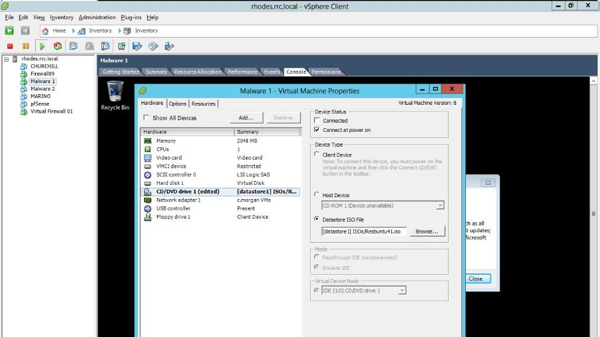

Exporting a VM
When the virtual machine has been properly configured, it is time to export the VM so that it can be distributed and reimported to be used by another person.
Before exporting, it is most important to take note of a bug in ESXi. If an ISO is the currently selected option for CD/DVD Drives, then any import will error and fail. Therefore, it is imperative that before exporting, the VM settings are changed so that the DVD drive is connected to a physical host drive as shown below. If this mistake is made, refer to this documentation to fix it: http://lukebarklimore.wordpress.com/2012/10/25/esxi-5-1-fixing-failed-to-deploy-ovf-package-the-task-was-canceled-by-a-user/.
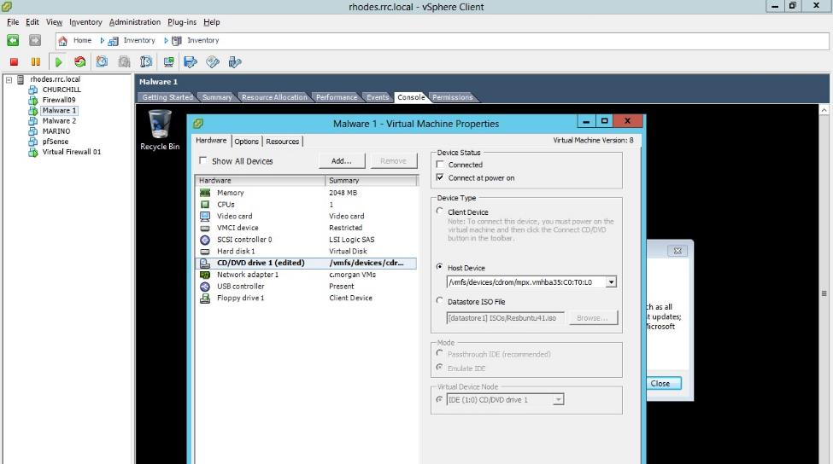
With all of the correct settings in place, the VM can now be exported. There are two options for exporting: OVA and OVF. OVAs are all-inclusive packages whereas OVFs have separate machine manifests and hard disk files. OVAs should always be used for the sake of simplicity.
Any virtual machine which is going to be exported must be powered off at the time of export.
Select the virtual machine to be exported in the left pane.
Go to File --> Export --> Export OVF Template...
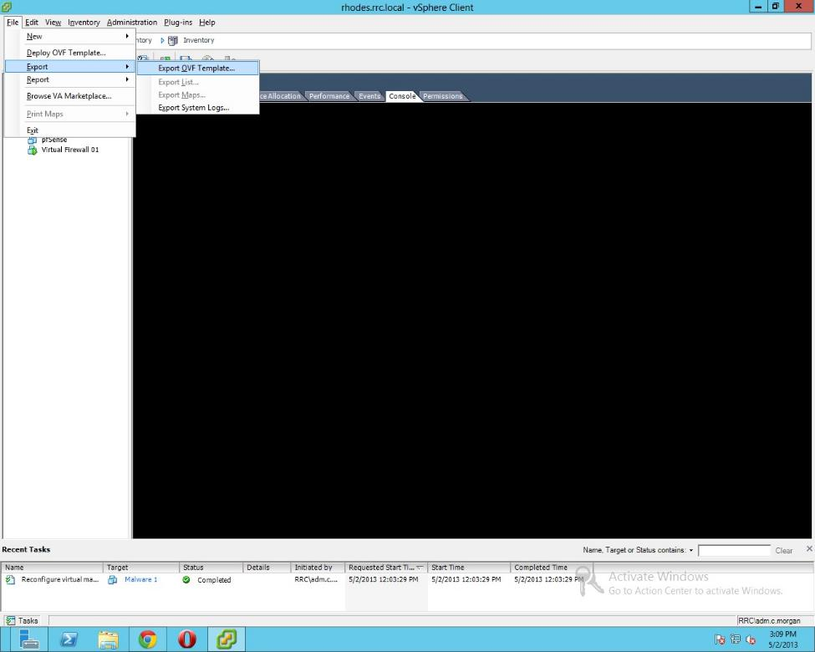
In the resulting screen, name the machine as appropriate and select a location to locally export the OVA to. Click OK to begin the export.
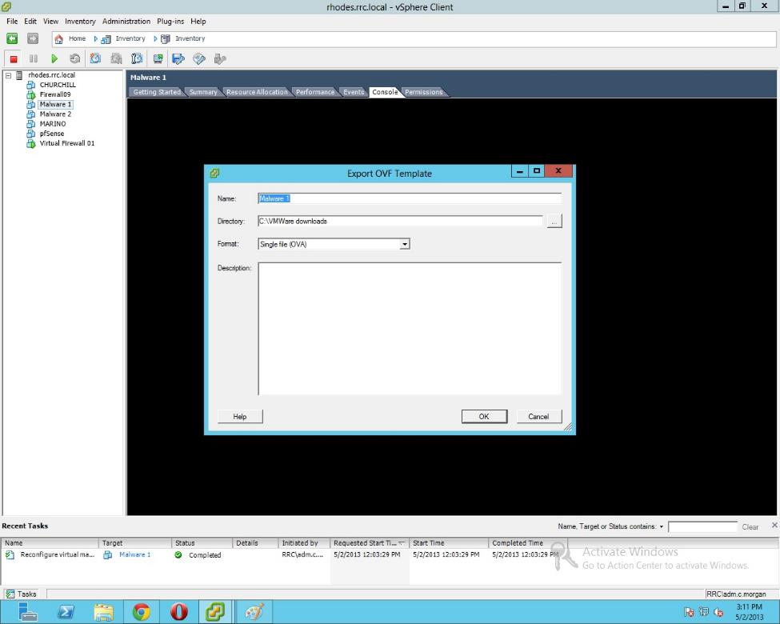

Importing OVAs
To import a virtual machine, simply go to File --> Deploy OVF Template.
In the resulting window, select the OVA to import. Click Next, select an appropriate name and the default options throughout this wizard, unless a special configuration is required.
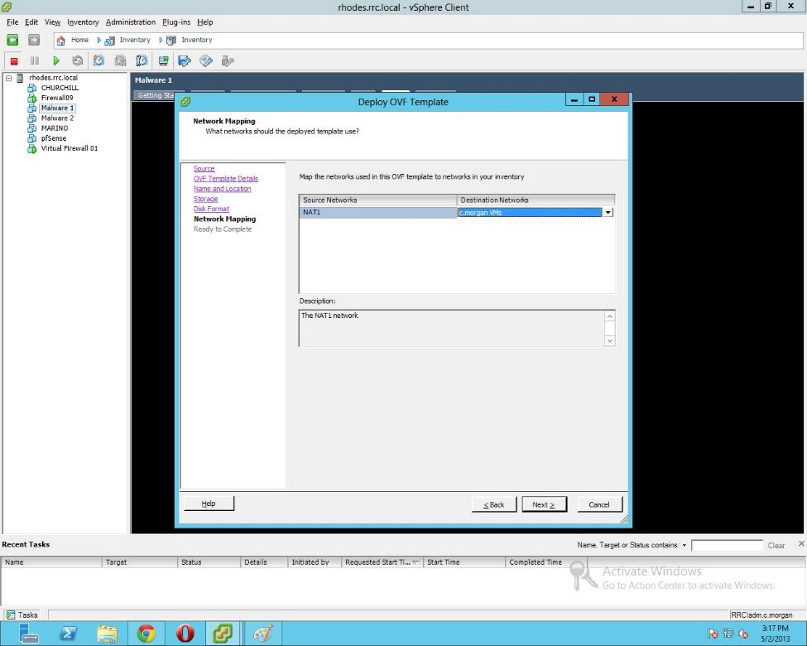
Click Next and Finish to begin the import.
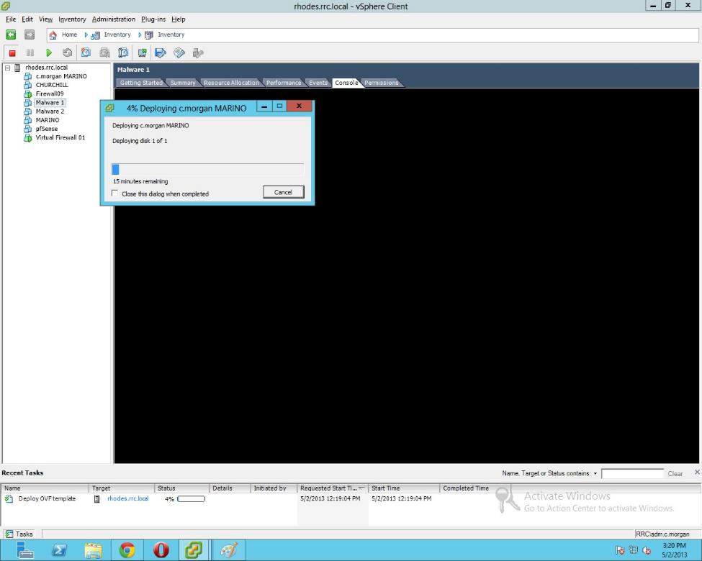

Setting Permissions on VMs
The final step to completing the setup of virtual machines is to appropriately select permissions for them. You can give individual users varying levels of access over virtual machines, but for this simple example we will just give individuals administrator access over machines they own. Anybody in the administrators group already has administrative access over any machine on the ESXi system since these rights were provided system-wide earlier in this setup guide. The process for assigning individual rights is similar to this earlier process.
Select the left pane virtual machine which needs to have its permissions edited.
In the right pane, select "Permissions."
Right-click in the resulting white space and select "Add Permission..."
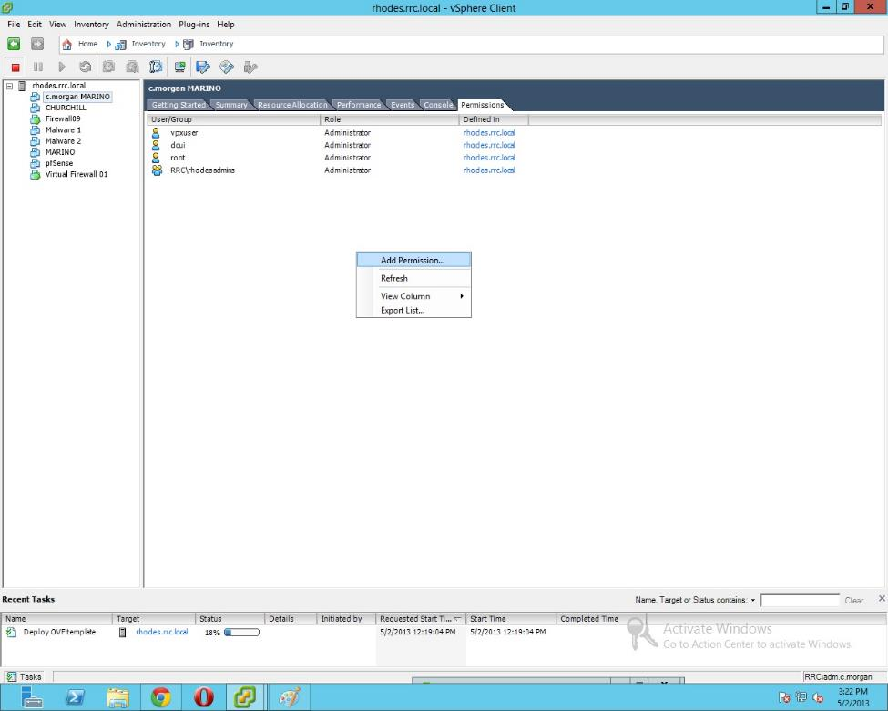
Change Assigned Role to Administrator and select Add... in the Users and Groups box.
In the Select Users and Groups window, change to the AD domain and search for the appropriate user. Select that user and click Add.
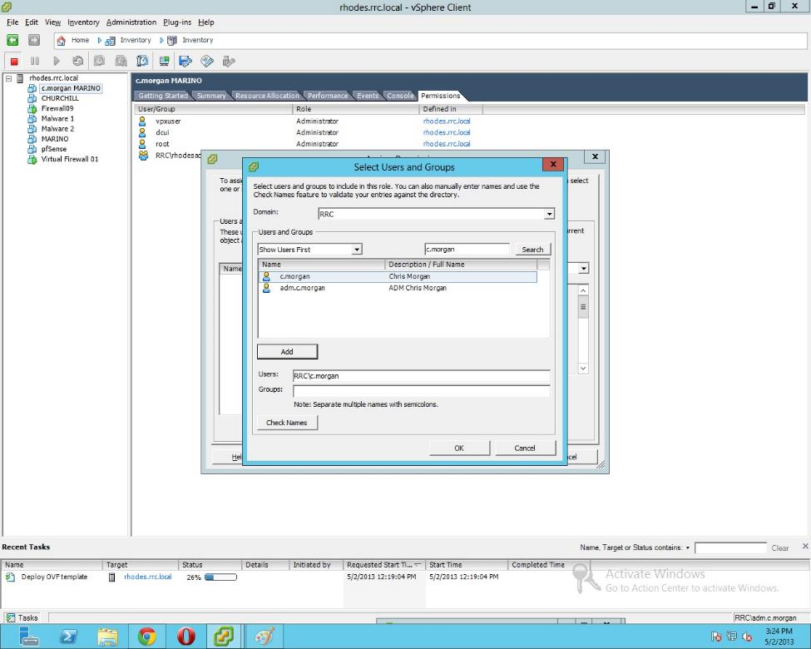
Click OK, then OK again to go back to the original vSphere window with the individual user permissions now in place.
